**The explanation of the design and UML class diagrams:**

1. Singleton Pattern:

Dashboard class implement Singleton Pattern.

**public** **class** Dashboard {

**private** **static** Dashboard *instance*;

**private** Dashboard() {

}

**public** **static** Dashboard getInstance() {

**if** (*instance* == **null**) {

*instance* = **new** Dashboard();

*intMap*();

}

**return** *instance*;

}

…

}

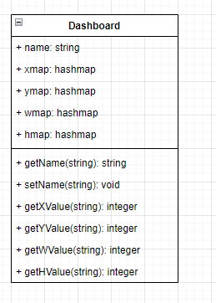

1. Composite Pattern:

Component is interface. Item class and ItemContainer class implement Component interface.

